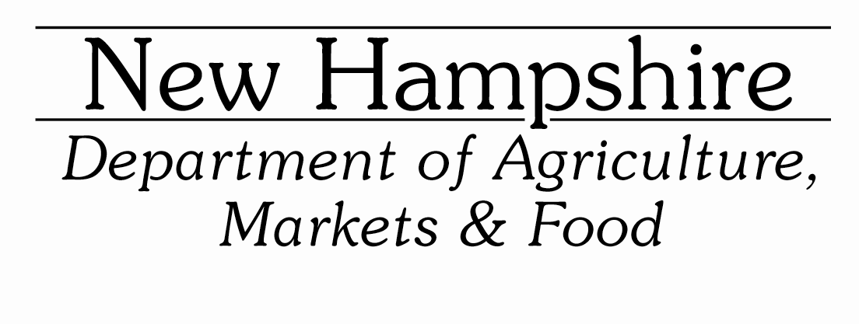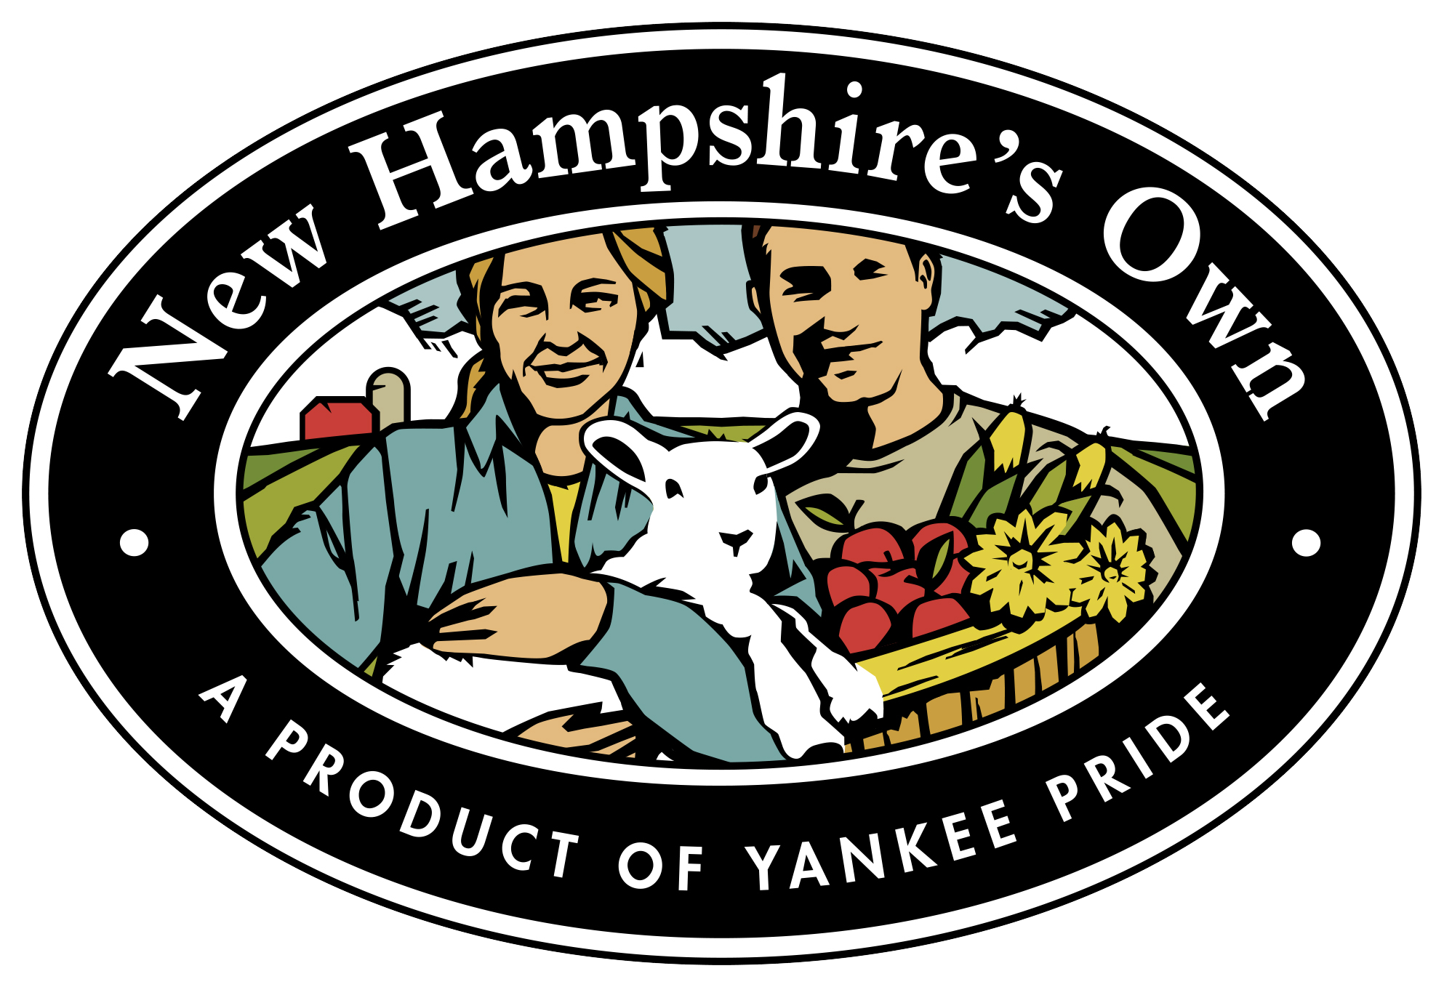

New Hampshire Specialty Crop Block Grant Program
H.R. 133 Stimulus Funding
Request for Proposals
Application Deadline April 25, 2022

Program Overview: The New Hampshire Department of Agriculture, Markets & Food (NHDAMF) is pleased to announce a special round of Specialty Crop Block Grant Program (SCBGP) funds for projects that solely enhance the competitiveness of specialty crops in New Hampshire. In addition to the regular SCBGP funding authorized the federal Farm Bill, the United States Congress awarded extra one-time SCBGP funding to state departments of agriculture due to the COVID-19 impacts on the food system under House Resolution 133 (“H.R. 133 Stimulus Funding”).

The requirements and procedures listed below are based on federal rules and regulations for SCBGP funding. More information is also available at http://agriculture.nh.gov/divisions/agricultural-development/grant-program.htm

Purpose: The New Hampshire Department of Agriculture, Markets & Food (NHDAMF) is eligible to receive funding from the United States Department of Agriculture (USDA), Agricultural Marketing Service (AMS) under the Specialty Crop Block Grant Program (SCBGP). The NHDAMF wishes to offer eligible New Hampshire organizations the opportunity to apply for a portion of these funds under the New Hampshire Specialty Crops Grant Program to conduct projects that enhance the competitiveness of NH Specialty Crops. Specialty Crops are defined as: fruit, vegetable, nursery, floriculture, herb, maple, Christmas tree and honey crops. For a complete list of eligible and ineligible crops visit the USDA AMS website at https://www.ams.usda.gov/services/grants/scbgp/specialty-crop

H.R. 133 Stimulus funding may be used for projects that respond to COVID-19 impacts. This includes funding to organizations for specialty crop enhancing projects to assist farmworkers, projects to fund farmers, food businesses, and other relevant entities to respond to risks and supply chain disruptions.

Examples of allowable organization project costs include:
- Personal Protective Equipment (PPE): Single items must not cost more than $5,000 per unit price. (e.g. one box of masks counts as a unit, not each separate mask).
- Facility adjustments as “Rearrangement and Reconversion Costs,” including installation of plexiglass barriers and other spacing adjustments to protect employees and the public from potential COVID-19 exposure. However, individual items should be considered supplies and must cost less than $5,000 per item.
- General purpose equipment over $5,000 is allowable if it is rented or leased.
- Vaccination costs, such as paying stipends to cover leave and travel time.
- Worker housing to protect employees from COVID-19 exposure, as a direct cost connected to the purpose of the SCBGP and the objectives of the project. This does not include construction or expansion of facilities.

Additionally, organization projects may also address traditional SCBGP topics with this funding such as:
- Addressing local, regional and national challenges confronting specialty crop producers, including topics such as Food Safety, Pest and Disease Prevention and Control, Technology Development
- Research and development relevant to specialty crops
- Leveraging efforts to market and promote specialty crops
- Expanding availability and access to specialty crops

Funds: All reasonable proposals with appropriate format and documentation will be considered. Selection is a competitive process based on the merits of the application and support materials. No match is required by the recipient, but in-kind or other services will enhance the application. A total of approximately $300,000 is available for the New Hampshire 2021 H.R 133 Stimulus Funding SCBG program.

Selected applications will be included in the New Hampshire state application package to USDA for these SCBGP funds. Applicants that are selected to be part of the New Hampshire state application will be notified prior to the submission of the application to USDA. Award notification from USDA is expected in September of 2022. Projects must gain final spending approval by the New Hampshire Governor & Executive Council. Project leaders may be asked to attend the Governor & Executive Council meeting where the project will be discussed, to answer any project specific questions. Plan on funding being approved no sooner than March of 2023 to start your projects.

Eligibility: NHDAMF is seeking proposals from eligible commodity groups, agriculture organizations, colleges and universities, municipalities, state agencies, and non-profit organizations for this grant program, provided their proposals meet all the specifications in this Request for Applications and the USDA’s Notice of Federal Assistance. These projects must aim to enhance the production and competitiveness of New Hampshire specialty crops. In order to be eligible to participate, applicants must reside in, or their business or educational affiliation must be in the State of New Hampshire. Individual businesses are not eligible.

Selected applicants must have a Data Universal Numbering System (DUNS) number and provide the number to NHDAMF. Failure to do so will result in withdrawal of any awarded grant. Obtaining a DUNS number is free for all entities doing business with the Federal government. For information about applying for a DUNS number, please visit the Dun & Bradstreet online registry at http://fedgov.dnb.com/webform.

Grants are not available to offset the grantee’s normal operating expenses. Funding is not available for political support purposes or memberships in professional societies or trade organizations. Grant funds may not be used for programs the applicant is already funding. Funds may not be used for construction purposes. Funding is not available for individuals or businesses (must be a recognized entity as described above). See more eligibility information at: http://agriculture.nh.gov/divisions/agricultural-development/grant-program.htm.

Preference will be given to those proposals that appear to give the broadest benefit to the New Hampshire Specialty Crop industry. Projects must be completed by September 29, 2025.
Projects cannot begin until the USDA has made their official award announcement and approvals have been obtained from New Hampshire authorities. Do not plan on funds being available for the project until March of 2023, at the earliest. The project final report will be due in December, 2025 (if the project is completed in 2023 or 2024, the final report will be due that year).

Accounting: Applicants shall maintain an accurate record of expenditures incurred and shall submit, annually and upon completion of the project the following:

      - A full financial statement summarizing expenditures
      - Copies of all paid invoices with copy of canceled checks attached
      - A report on the project and its results in terms of objectives stated
      - Copies of material produced, when feasible
How to Apply

To apply: All applications must be digitally submitted by 4 pm on April 25, 2022 with the designated information and format as indicated below. Applications must be submitted providing the requested information and precisely following the USDA SCBG application format.

Application must include:
- Completed cover page
- Completed Project Profile Template
- Any support documents
- 4 printed copies of entire application (see below)

All documents and instructions are available on the NHDAMF website: http://agriculture.nh.gov/divisions/agricultural-development/grant-program.htm

Please submit your proposal digitally in MS WORD (or compatible) format only, using the provided USDA SCBG Project Profile Template. No PDFs. Do not use excessive formatting—no page numbers, footnotes, corporate headings--please stick to the basics. Selected proposals are incorporated into a State Plan document to be sent to USDA digitally, again, following a specific format. Send to gail.d.mcwilliam.jellie@agr.nh.gov.

Additionally, four (4) printed copies of the entire proposal must be received in our office no later than 4 pm on April 27, 2022.
Mail to:
HR 133 SCBG
NH Dept. of Agriculture, Markets & Food
PO Box 2042
Concord, NH 03302-2042

Or deliver to:
NH Dept. of Agriculture, Markets & Food
25 Capitol St. (second floor)
Concord, NH 03301

Application Evaluation

All eligible applications will be reviewed by a selection committee and recipients chosen on the merits of the project as put forth in the application. Selected applications will be submitted to USDA AMS as part of the New Hampshire state application for the HR 133 Funding SCBGP. There is no guarantee of project funding until the determination of USDA AMS and final approval by the New Hampshire Governor & Executive Council.

Selection will be determined based on how well the application meets the following:

1. Does the application meet all the submission requirements?
2. Does the project increase the competitiveness of specialty crops? How?
3. Is the project needed by the industry?
4. Does the project affect specialty crops as a whole and not an individual in
any way? Does the application elaborate on how that will be accomplished?
5. Is there a well constructed budget to show in the highest detail possible how funds are to be expended?

All grant recipients will be required to sign an official State of New Hampshire agreement with the NHDAMF indicating their commitment and responsibilities toward completing the project in a manner consistent with state of New Hampshire and USDA policies. Recipient organizations must be registered with the NH Secretary of State (or could register) before final approval and fund distribution. NHDAMF is authorized to view all project details and certify the project as complete. Semi- annual, annual and final written project reports are required and are to be submitted following a specific format. Payment of funds to the applicant may be made in installments contingent upon satisfactory completion of the project tasks.

For more information, contact Gail McWilliam Jellie at 271-3551 or gail.d.mcwilliam.jellie@agr.nh.gov.

